Ex no: 2

Date:

**DML Commands – INSERT, SELECT, UPDATE, DELETE**

**AIM:**

To insert, select, update and delete using DML command.

1. **Create a table bank**

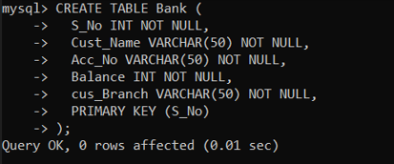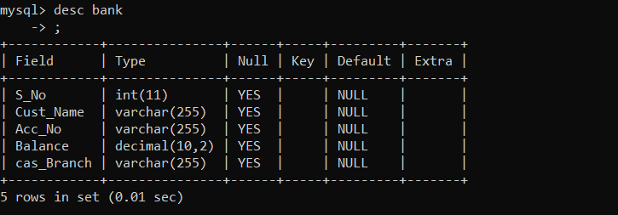

1. **Insert 5 rows into the table bank.**

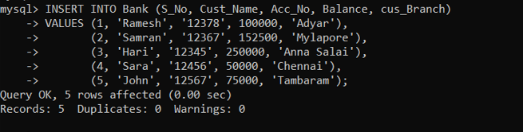

1. **Simple select all the fields in the table.**

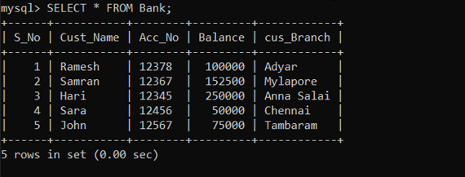

1. **Update the Cus_branch in the second row as Pondicherry.**



1. **Select with various clause**

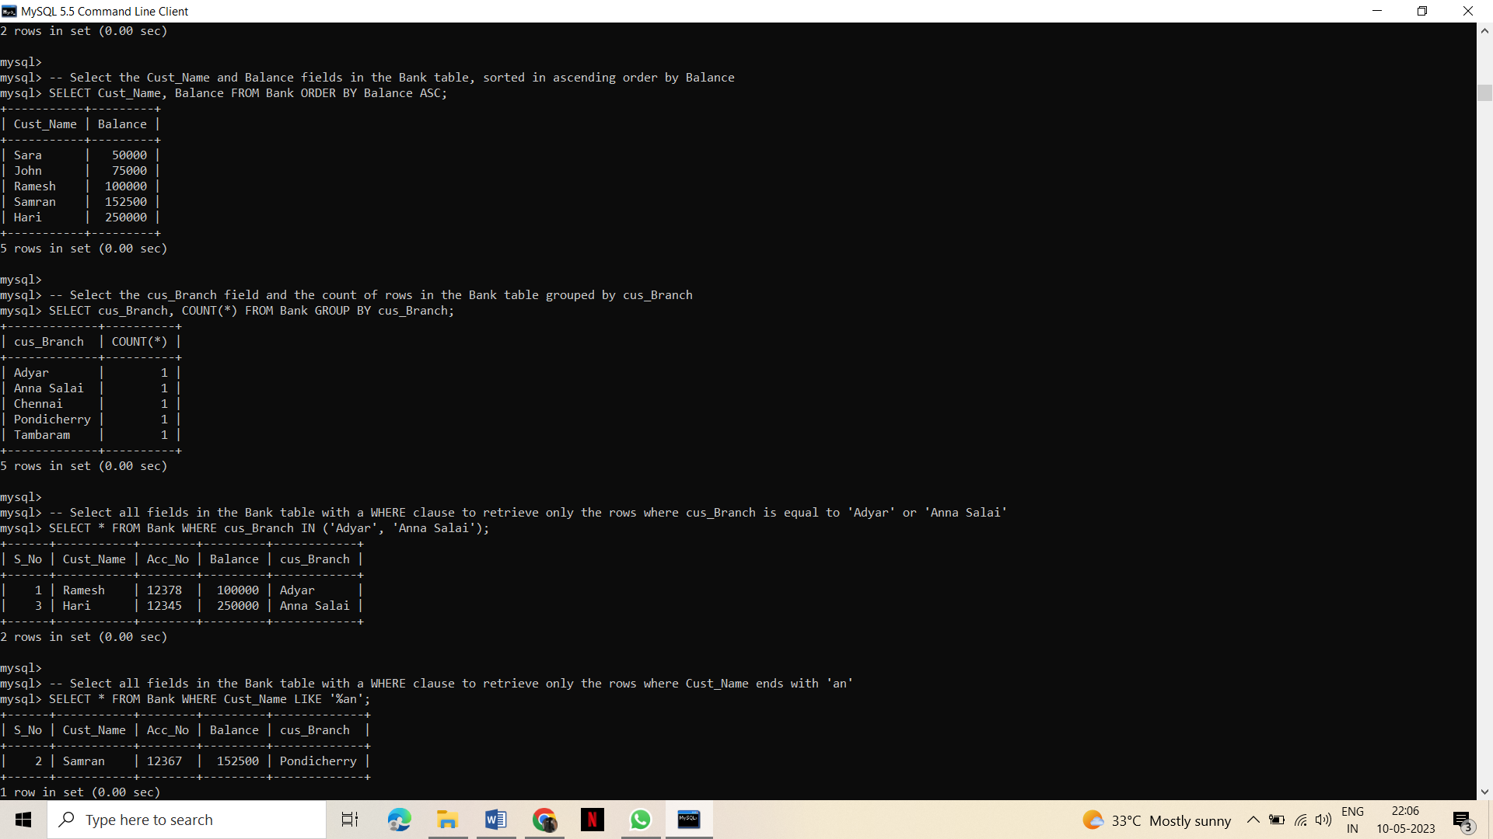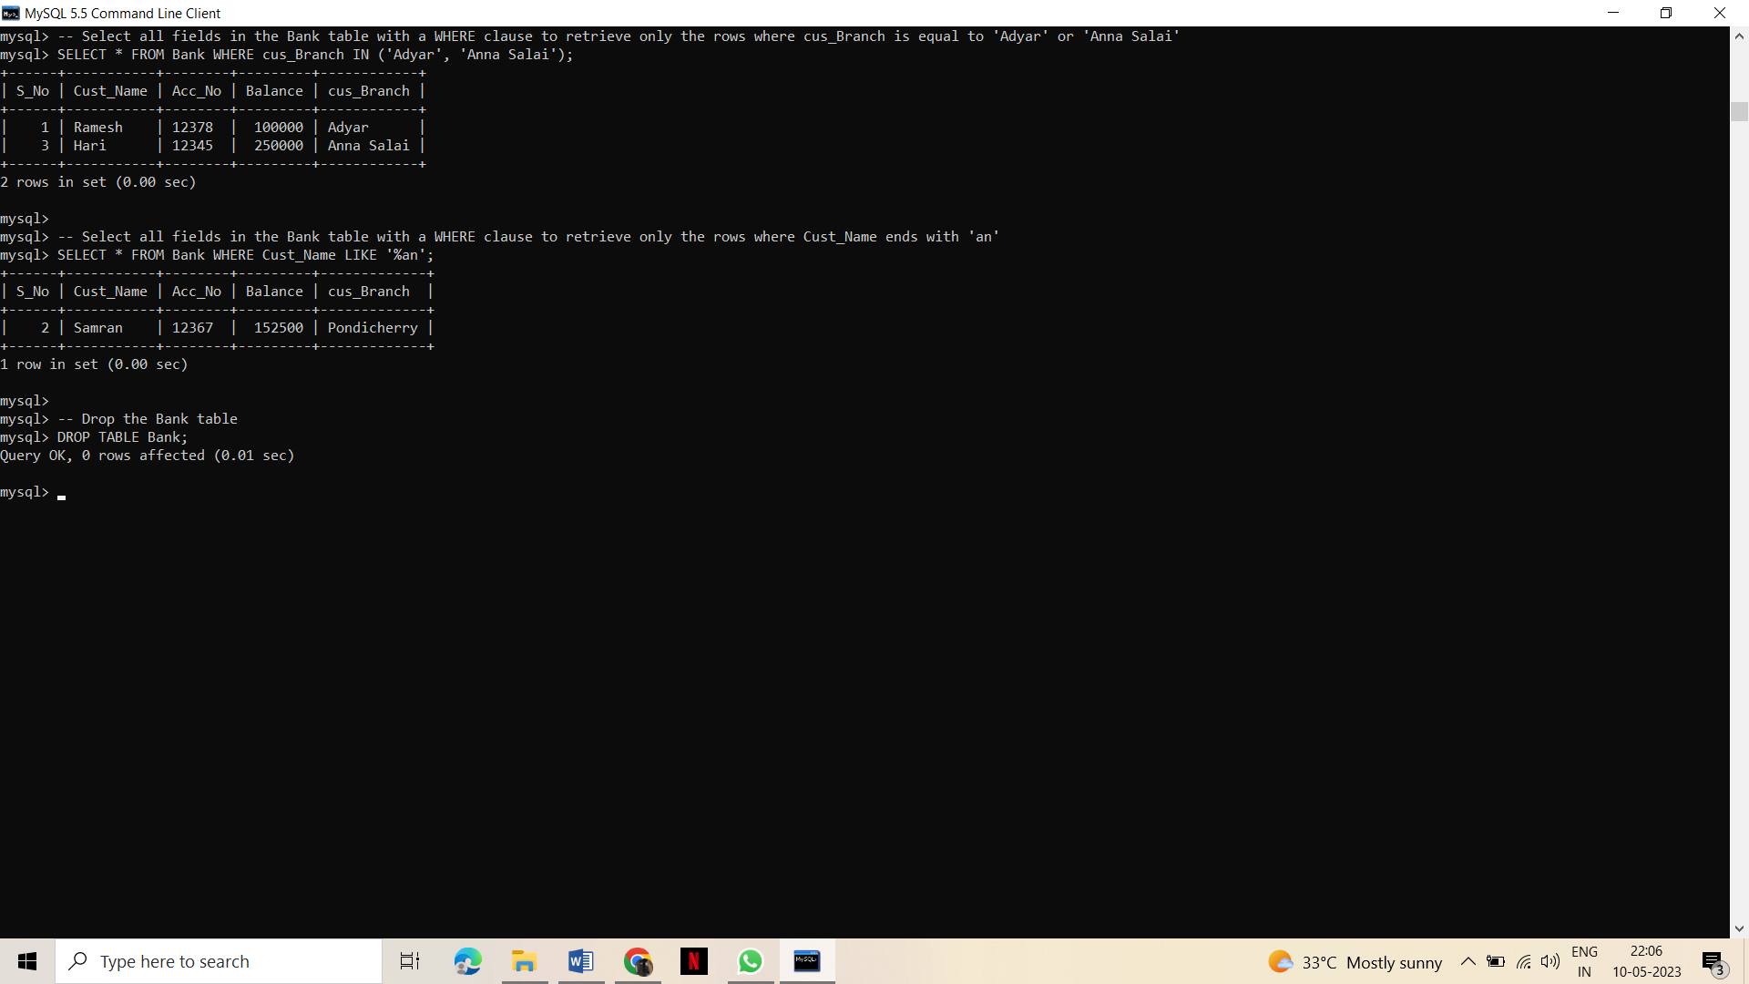

**Result:**

Tables are created, five rows have been inserted, selected,updated and selected with various clause.